**CHAPTER 1**

**INTRODUCTION**

In an effort to promote environmental awareness and encourage sustainable living, a group of dedicated college students embarked on a transformative journey to Abbigere, a vibrant locality in Bangalore. Recognizing the growing issue of plastic pollution and its harmful impact on the environment, the team initiated an awareness campaign advocating for the use of paper bags over plastic. Their goal was not only to reduce plastic consumption but also to instill a lasting sense of responsibility among community members regarding sustainable choices.

Abbigere, known for its unique mix of urban vibrancy and natural beauty, provided the ideal setting for this initiative. The campaign was designed to educate residents about the detrimental effects of plastic waste, particularly its role in pollution, soil degradation, and harm to wildlife. By introducing eco-friendly paper bags as a viable alternative, the students aimed to encourage a shift towards a greener lifestyle.

Beyond simply replacing plastic bags with paper, the initiative sought to address broader environmental concerns, including the importance of afforestation. Trees play a crucial role in maintaining ecological balance, absorbing carbon dioxide, improving air quality, and supporting biodiversity. As part of the campaign, informational materials were distributed alongside paper bags to educate the community about the benefits of tree planting and conservation.

A key focus of this initiative was community engagement and participation. The students actively interacted with local residents, engaging in discussions about sustainable practices and emphasizing the importance of individual contributions to environmental conservation. By fostering grassroots involvement, the campaign aimed to create a long-term cultural shift toward sustainability, ensuring that the message extended beyond a one-time event.

The enthusiasm and commitment displayed by the students in this endeavor highlight the power of collective action in driving meaningful change. Through their efforts, they not only provided an immediate alternative to plastic bags but also laid the groundwork for a more sustainable future in Abbigere. The campaign serves as an inspiring example of how small, community-led initiatives can have a significant impact on environmental preservation.

By taking a stand against plastic pollution and advocating for afforestation, the initiative in Abbigere represents a step towards a cleaner, healthier planet. It reinforces the idea that every action, no matter how small, contributes to the greater goal of environmental sustainability.

 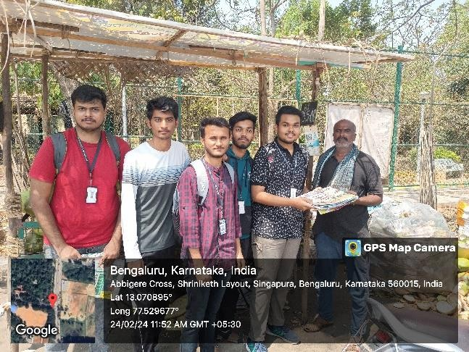

**CHAPTER 2**

**OBJECTIVE**

The primary objective of the environmental awareness campaign in Abbigere, Bangalore, was to advocate for sustainable practices by replacing plastic bags with eco-friendly paper bags. This initiative aimed to promote afforestation, reduce plastic pollution, and foster long-term environmental responsibility within the community. By educating residents and actively involving them in the campaign, the project sought to create a lasting impact on local habits and attitudes towards sustainability.

**Specific Objectives:**

**1. Paper Bag Distribution – Reducing Plastic Dependency**

* The campaign’s foremost goal was to **distribute eco-friendly paper bags** as a sustainable alternative to plastic.
* By making paper bags **easily accessible**, the initiative aimed to **reduce the consumption of plastic bags** and encourage their **gradual replacement** in daily use.
* Each paper bag distributed carried a **message encouraging residents** to adopt sustainable choices and **minimize plastic waste**.

**2. Raising Awareness on Plastic Pollution**

* The initiative sought to educate the local community about the harmful environmental effects of plastic usage.
* Awareness sessions highlighted issues such as land and water pollution, harm to wildlife, and the long decomposition time of plastic waste.
* Through interactive discussions, residents were encouraged to make responsible choices by opting for biodegradable and recyclable materials.

**3. Advocating for Afforestation and Ecological Conservation**

* The campaign emphasized the critical role of afforestation in addressing climate change, improving air quality, and supporting biodiversity.
* Informational pamphlets were distributed alongside the paper bags, explaining the importance of trees in maintaining ecological balance.
* Residents were encouraged to support local afforestation efforts, including tree planting initiatives in their neighborhoods.

**4. Encouraging Behavioral Change in the Community**

* A key goal was to inspire a shift in consumer behavior, encouraging individuals to adopt sustainable habits.
* The initiative sought to make paper bag usage a normal practice, reducing the community’s reliance on plastic bags.
* Through consistent messaging and engagement, the campaign aimed to make sustainability an integral part of daily life.

**5. Strengthening Community Engagement and Participation**

* The campaign actively involved residents of all ages, ensuring broad participation and engagement.
* By creating a dialogue about sustainability, the initiative aimed to build a sense of shared responsibility in environmental conservation.
* Encouraging local participation in future sustainability projects, the initiative sought to lay the foundation for continued efforts in waste management and afforestation.

**6. Establishing a Model for Future Environmental Initiatives**

* The success of this campaign was designed to serve as an example for similar sustainability projects in other areas.
* The initiative aimed to inspire further community-driven environmental efforts, reinforcing the importance of local action in achieving global sustainability goals.

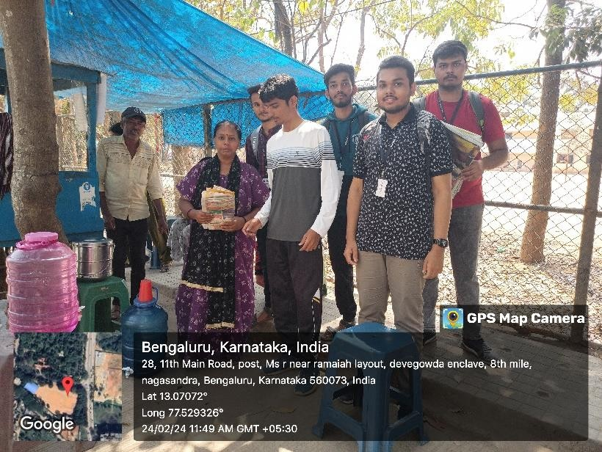

**CHAPTER 3**

**ABOUT THE PLACE**

**Abbigere** is a vibrant locality situated in the northern part of **Bangalore, Karnataka**. Over the years, it has transformed from a semi-urban region into a rapidly developing residential and commercial hub. Despite urban expansion, Abbigere retains a **blend of natural greenery and city life**, making it an ideal place for **environmental conservation efforts** such as the promotion of paper bags and afforestation initiatives.

**1. Geographical and Environmental Aspects**

* Geographical Location: Abbigere is strategically located near key areas such as Vidyaranyapura, Jalahalli, and Yeshwanthpur, making it well-connected to other parts of Bangalore.
* Climate and Weather: Like the rest of Bangalore, Abbigere experiences a moderate climate throughout the year, with pleasant winters, warm summers, and a monsoon season that supports lush greenery.
* Natural Green Cover: Despite ongoing urbanization, Abbigere still has patches of green spaces, parks, and tree-lined streets, which contribute to its relatively clean air and scenic beauty.

**2. Urbanization and Environmental Concerns**

* Growing Urbanization: Due to its proximity to industrial zones and IT hubs, Abbigere has seen a rise in population and infrastructure development.
* Plastic Waste Issue: Like many urbanizing areas, Abbigere has faced an increase in plastic usage and waste disposal challenges, making it essential to introduce sustainable practices.
* Afforestation Needs: With growing construction activities, there is a need to preserve and expand green cover to maintain ecological balance and improve air quality.

**3. Community and Lifestyle**

* Diverse Population: Abbigere is home to a mix of working professionals, students, and local business owners, creating a dynamic community.
* Local Markets and Businesses: The area has many small-scale vendors, street markets, and grocery stores where plastic bag usage is prevalent, highlighting the importance of encouraging sustainable alternatives like paper bags.
* Educational Institutions: Presence of schools and colleges makes it an ideal location for student-led initiatives, such as the paper bag promotion campaign, which can help raise awareness among younger generations.

**4. Why Abbigere Was Chosen for the Campaign**

The decision to conduct the **paper bag promotion campaign** in Abbigere was driven by multiple factors:

* High Plastic Consumption: With numerous local vendors and commercial establishments, plastic bags are widely used, contributing to environmental pollution.
* Community Engagement Potential: The diverse and active population provided an opportunity to spread awareness effectively.
* Green Preservation Needs: The ongoing urban expansion posed a risk to existing green spaces, making afforestation advocacy crucial.
* Strategic Location: As a well-connected area, Abbigere serves as a model for sustainability initiatives, encouraging surrounding localities to adopt similar eco-friendly practices.

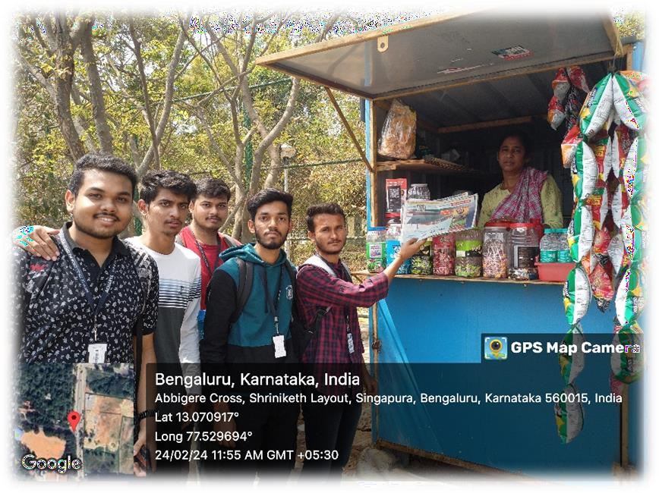

**CHAPTER 4**

**CONDUCTION OF THE ACTIVITY**

The environmental awareness campaign promoting paper bags over plastic in Abbigere, Bangalore, was executed through a structured and well-coordinated approach. The initiative involved extensive planning, team organization, community participation, and educational outreach, ensuring its effectiveness and long-term impact.

**1. Planning and Preparation**

Before the execution of the activity, a **detailed action plan** was developed to ensure smooth implementation.

**A. Research and Pre-Assessment**

* The team conducted preliminary research to assess the level of plastic consumption in Abbigere.
* Discussions with local vendors, shopkeepers, and residents provided insights into the extent of plastic bag usage and the community's willingness to adopt sustainable alternatives.
* The importance of afforestation as a complementary aspect of sustainability was also identified.

**B. Resource Collection and Paper Bag Procurement**

* Eco-friendly paper bags were procured in large quantities from sustainable sources.
* Informational pamphlets and posters were created to educate the community on the harmful effects of plastic and the benefits of switching to paper bags.
* A team was assigned to design and print banners, ensuring visibility and outreach during the campaign.

**C. Team Formation and Role Assignment**

To execute the campaign efficiently, participants were divided into specialized teams, each responsible for different aspects of the activity:

1. Distribution Team – Responsible for handing out paper bags to shopkeepers, residents, and businesses.
2. Awareness Team – Engaged with the community, spreading knowledge about plastic pollution and sustainable alternatives.
3. Documentation Team – Recorded photographs, videos, and testimonials to document the impact of the campaign.
4. Afforestation Advocacy Team – Educated people about tree planting and environmental conservation, encouraging pledges for afforestation.

**2. Execution of the Activity**

**A. Paper Bag Distribution Drive**

* The team visited major marketplaces, grocery stores, and residential areas to distribute eco-friendly paper bags.
* Each paper bag carried an environmental awareness message, urging people to replace plastic with paper.
* Shopkeepers were encouraged to use paper bags for their customers instead of plastic ones.

**B. Community Engagement and Awareness Campaign**

* Volunteers interacted with local residents, vendors, and students to discuss the negative environmental impact of plastic bags.
* Door-to-door campaigns and public interactions were conducted to spread awareness.
* Educational sessions highlighted plastic’s contribution to pollution and its effect on soil, water bodies, and marine life.
* The health hazards associated with plastic usage were explained, encouraging people to opt for safer alternatives.

**C. Afforestation Awareness and Environmental Pledges**

* Informational pamphlets about the importance of trees in mitigating climate change were distributed.
* People were encouraged to take afforestation pledges, committing to plant and nurture trees.
* The team explained how afforestation helps in air purification, improving biodiversity, and combating climate change.

**D. Public Display and Promotional Efforts**

* Posters and banners were displayed in crowded public places to reinforce the message of sustainability.
* Some volunteers wore eco-friendly slogans on t-shirts to grab attention and start conversations.

**3. Response and Community Feedback**

**A. Positive Reception and Behavioral Change**

* Residents welcomed the initiative, with many pledging to reduce their plastic usage.
* Several shopkeepers agreed to switch to paper bags permanently, contributing to a plastic-free environment.
* People showed increased awareness and understanding of the importance of sustainable practices.

**B. Afforestation Interest and Commitment**

* Many individuals expressed interest in participating in local tree-planting programs.
* Some residents pledged to take care of existing green spaces in their community.

**4. Challenges Faced During Execution**

While the campaign was largely successful, a few challenges were encountered:

**A. Behavioral Resistance**

* Some community members were hesitant to change their habits, showing reluctance in adopting paper bags.
* Shopkeepers initially worried about the cost and durability of paper bags compared to plastic.

**B. Limited Awareness**

* Some residents lacked basic environmental knowledge, making it necessary to use simplified messaging and visual aids.

**C. Communication Barriers**

* Since Abbigere has a diverse population, language differences made it challenging to communicate effectively.
* Volunteers adapted by using bilingual pamphlets and local language engagement to connect better.

**D. Long-Term Commitment Concerns**

* Ensuring that the habit of using paper bags continued beyond the campaign required follow-up efforts.
* Collaboration with local authorities and environmental groups was suggested to sustain long-term engagement.



**CONCLUSION**

The paper bag promotion campaign in Abbigere was more than just an environmental initiative—it was a movement toward change, awareness, and responsibility. Through community engagement, education, and active participation, we witnessed how small, purposeful actions can ignite a larger cultural shift towards sustainability.

From the initial resistance to the warm acceptance of paper bags, from conversations about plastic pollution to heartfelt afforestation pledges, the campaign left an everlasting impact on the people of Abbigere. It was inspiring to see individuals embrace eco-friendly habits, proving that with the right awareness and encouragement, change is not only possible but inevitable.

Yet, this is just the beginning. Sustainability is not a one-time effort but a continuous commitment. The seeds of change we planted—both literally and figuratively—will flourish only if nurtured with perseverance and collective responsibility. As we move forward, we carry with us the hope that this initiative will inspire many more communities to take charge of their environment, one small step at a time.

Together, we are not just replacing plastic with paper; we are reshaping mindsets, restoring nature, and reclaiming the future of our planet.

**Key Takeaways from the Initiative:**

1. Reduction in Plastic Usage – The campaign successfully introduced an alternative to plastic bags, encouraging both residents and shopkeepers to make an eco-friendly switch.
2. Increased Awareness – The initiative helped people understand the harmful effects of plastic pollution and the benefits of using biodegradable materials like paper bags.
3. Afforestation Advocacy – Discussions on tree planting and environmental conservation inspired residents to take afforestation pledges, recognizing the crucial role of trees in sustainability.
4. Community Engagement – The campaign strengthened the bond between people and nature, fostering a sense of collective responsibility for environmental preservation.
5. Behavioral Shift – Initial resistance to change was gradually replaced with a willingness to adopt eco-friendly habits, demonstrating the power of persistence and education.